# **META-BOT**

*This document is for short proposal reviews and users with minimal or non technical background. Please expect frequent changes to this document that will reflect this goal accordingly. A more technical document will be released in the future.*

## **About**

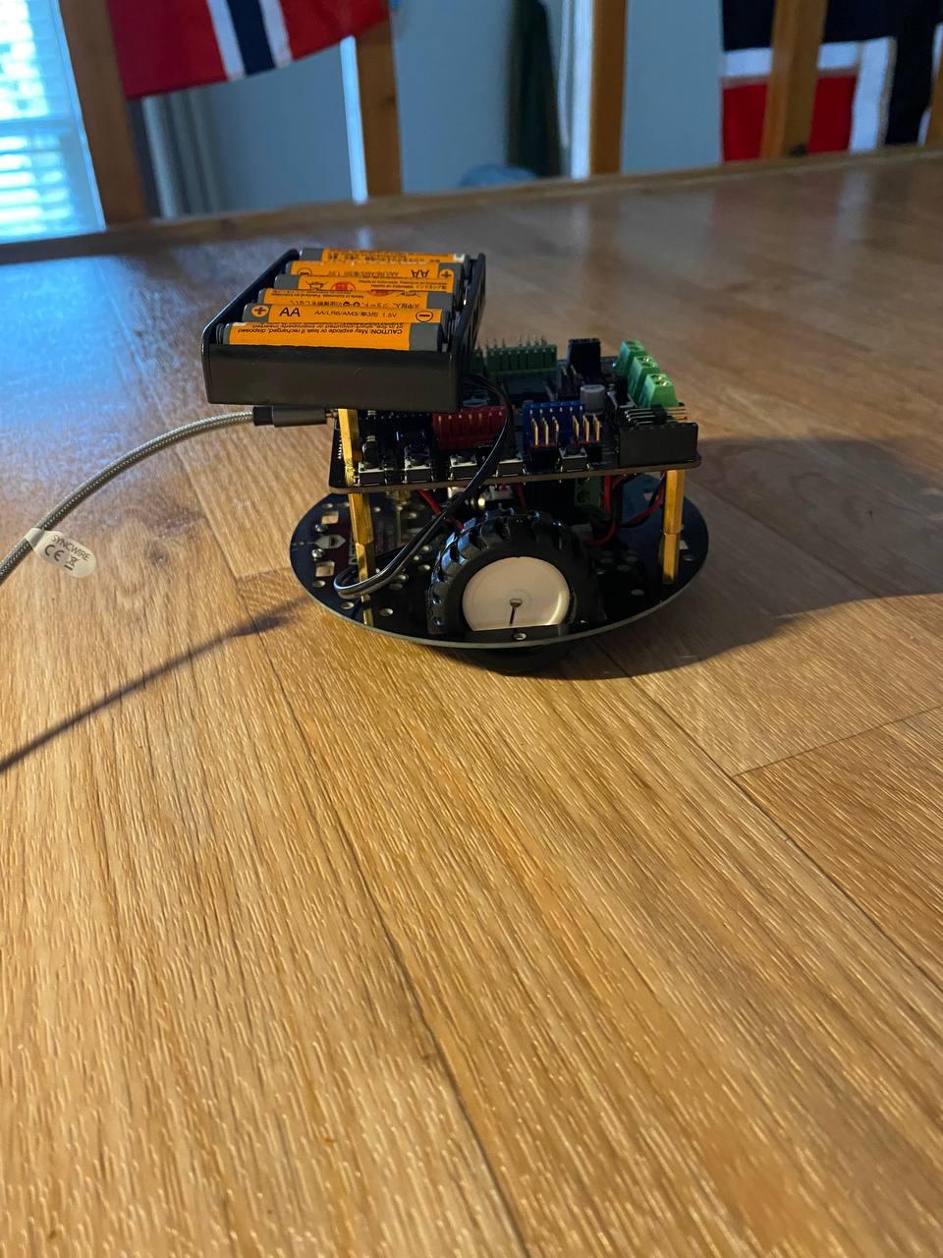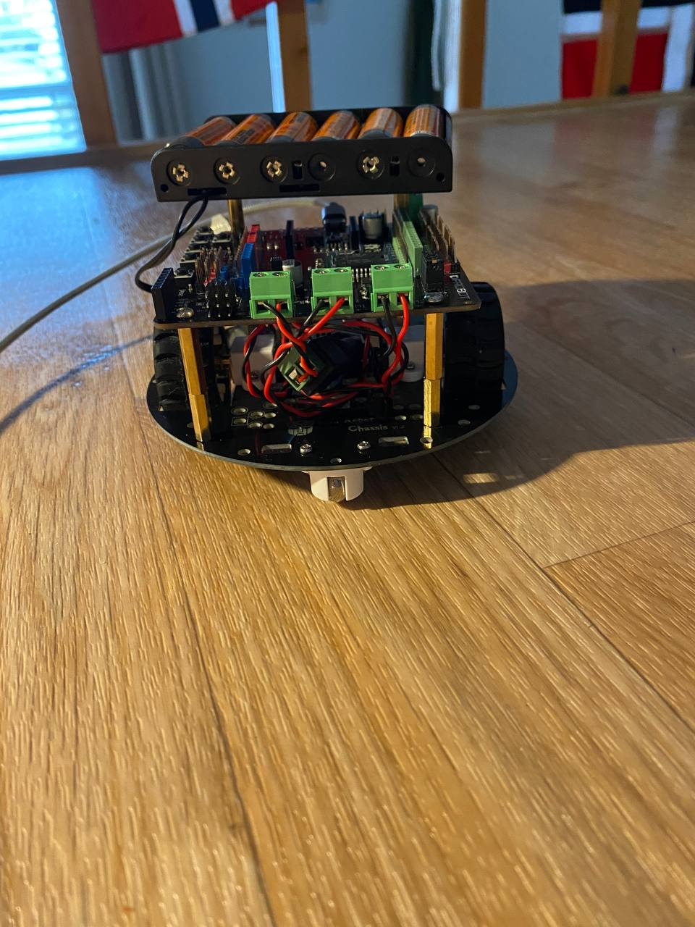

Meta-Bot is an easily accessible and controllable robot through the metaverse platform ROBLOX. Meta-Bot is an active ongoing project to give users access to robots and inspire interest in STEM and robotics. Footage is live-streamed using Twitch so users can see the robot in action.

## **Technologies**

### ROBLOX

ROBLOX is massive multiplayer online game and game creation system. Users from around the world can code, build, publish, and play millions of games produced by the community. ROBLOX has monthly active user count of 164 million, with over 50% being under the age of 16. [1][2]

### Twitch

Twitch is a live streaming service provided by Amazon geared towards gamers.

## **Framework**

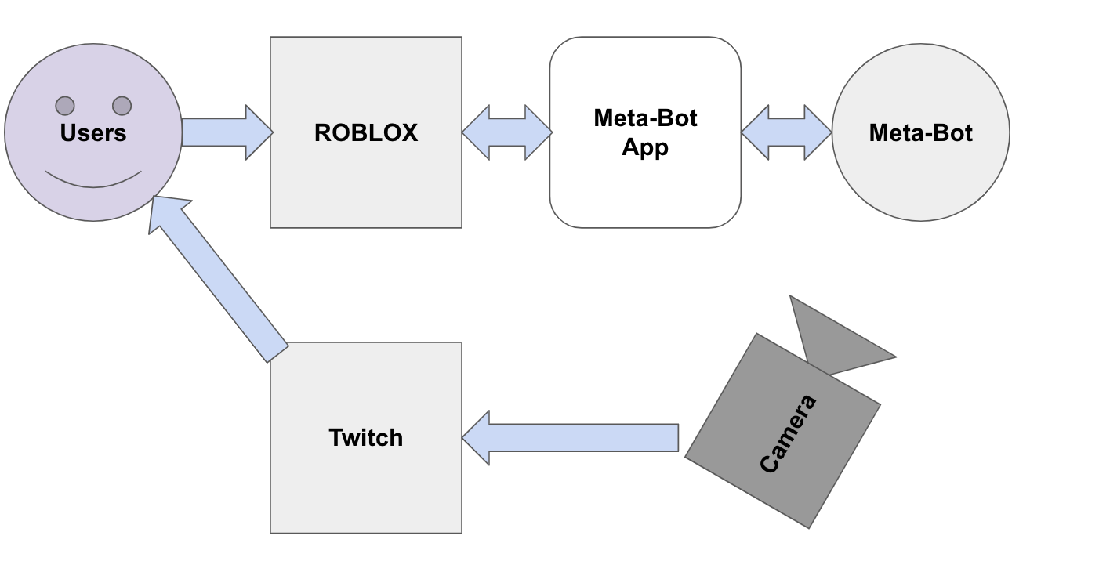

Meta-Bot is about giving the user/viewer access to robots. User input is taken through the ROBLOX Platform. This input is transmitted to the Meta-Bot App hosted in the cloud. This separate app parses data that is sent to a more readable format to Meta-Bot.

A wide angle camera captures the Meta-Bot field which is broadcasted to Twitch. The user can watch as the robot takes commands from the world and moves.

## **Current Functions**

### Navigation

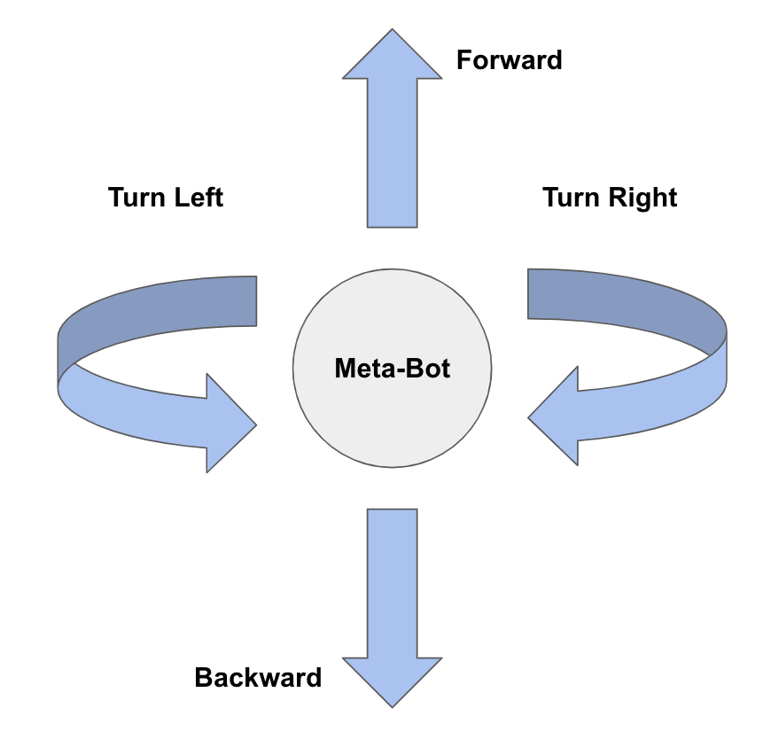

Meta-Bot can move forward or backwards with supplementary 90 degree turns to allow for wide range of motion.

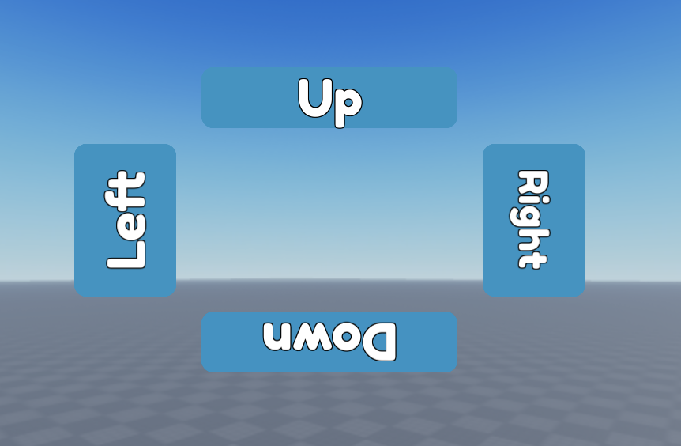

Robot navigation is controlled by a graphical user interface (GUI) through the ROBLOX platform. Users can send requests for robots to go coordinate directions.

## **Future Work**

### Robot Environment

Meta-Bot is currently hosted in the home of author (@han#3427) with no permanent or stable hosting solution. Current hopes are to build a smaller [Robotarium](https://news.gatech.edu/archive/features/robotarium-robotics-lab-accessible-all.shtml)-like environment to give a sense of professionalism.

### ROBLOX Experience

The ROBLOX experience hosting Meta-Bot only includes the GUI. There is no live user feedback allowing the user to understand the robot’s current and future actions. The experience does not present any incentive for the user to be engaged with others or with experience itself. Aesthetics and social activities will be added to the host experience.

### Team Based Activities

The robot currently only takes commands but does not have any end goal for users in mind. Future work will incorporate goal-oriented activities for users and the robot. This can include users working together to drive the robot to certain points, maze running, soccer, and more.

### Learning Modules

Meta-Bot is to inspire STEM and robotics education. Within the ROBLOX experience, short courses geared towards understanding robotics and how they work will be implemented.

### Fine Movement

Meta-Bot is limited to pre-timed 2 directional movements and 90 degree turns. Future work will implement finer turning radiuses and movement timing.

### Twitch Feedback

Users cannot tell when their movement is being broadcasted. Alongside ROBLOX active updates, improvements to the Twitch broadcast will allow users to understand whose command is being run at any given moment.

## **About the Author(s)**

### [Hannah](https://hanphps.dev/) *(@han)*

Hannah is a first year graduate student in Electrical Engineering at Georgia Tech. She graduated with her Bachelors in Mechanical Engineering in 2021. Her research encompasses biologically inspired robots, robot networks, and robotics education. She has been an active ROBLOX player since 2009. ROBLOX has inspired her to pursue her interest in STEM and degrees in engineering.

## **Contributions & Support**

All forms of contribution & support (programming, building, critiques, opinions, and words of encouragement) are happily appreciated and can be arranged by contacting the main author (@han)

## **References**

[1] Browning, Kellen (August 16, 2020). "You May Not Know This Pandemic Winner, but Your Tween Probably Does". The New York Times. Retrieved August 17, 2020.

[2] Lyles, Taylor (July 21, 2020). "Over half of US kids are playing Roblox, and it's about to host Fortnite-esque virtual parties too". The Verge. Retrieved July 23, 2020.